

Name : Khizar Ali

Roll No: 22P-9269

Subject: PF LAB

**Problem: 1**

**Write a C program to print your name, roll no and section in separate lines.**

#include<stdio.h>

int main()

{

printf("My name is Khizar Ali \n");

printf("My ROll No is 22P-9269 \n");

printf("My section is BAI-223A \n");

return 0;

}

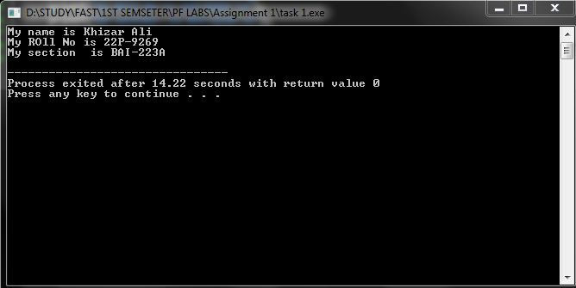

**Problem: 2**

**Write a program that prints the following patterns using printf statement.**

#include<stdio.h>

int main()

{

printf("Pattern 1 \n\n");

printf("****** \n");

printf("****** \n");

printf("****** \n");

printf("****** \n");

printf("****** \n\n\n");

printf("Pattern 2 \n\n");

printf("* \n");

printf("** \n");

printf("*** \n");

printf("**** \n");

printf("***** \n\n\n");

printf("Pattern 3 \n\n");

printf(" * \n");

printf(" ** \n");

printf(" *** \n");

printf(" **** \n");

printf("***** \n\n\n");

printf("Pattern 4 \n\n");

printf(" * \n");

printf(" *** \n");

printf("***** \n");

printf(" *** \n");

printf(" * \n\n\n");

return 0;

}

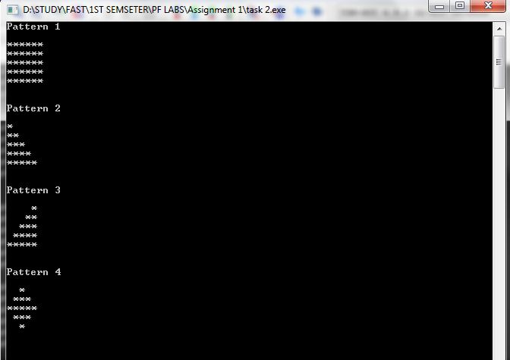

**Problem: 3**

**Write a program that calculates the area of a rectangle and print the result on screen.**

**The formula to calculate the Area is given below.**

#include<stdio.h>

int main()

{

float l, w ,Area ;

printf("Enter legth of rectangle \n");

scanf("%f",&l);

printf("Enter width of rectangle \n");

scanf("%f",&w);

Area = w * l ;

printf ("The area of rectangle is %.2f \n",Area);

return 0;

}

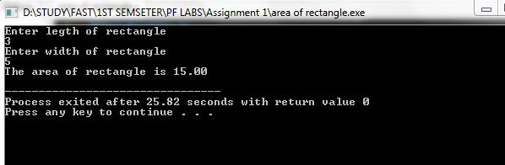

**Problem: 4**

**Write a program that takes the length, width and height of a parallelepiped and finds its volume. The formula to calculate the volume is given below.**

Volume = length * width * height

#include<stdio.h>

int main()

{

float length , width , hight , volume ;

printf("Enter length \n");

scanf("%f",&length);

printf("Enter width \n");

scanf("%f",&width);

printf("Enter hight \n");

scanf("%f",&hight);

volume = length * width * hight ;

printf("The area of parallelepiped is %.2f \n",volume);

return 0 ;

